What is Community Engagement?

October 2023

Copyright images © Photosymbols. Prepared by Scottish Community Development Centre
Introduction
Community Engagement is a way to involve people in decisions that affect them.

This includes working together to make decisions about services that affect people’s daily lives. These include services like the ones run by the NHS and the Council.

Community engagement means that organisations like the NHS and the Council speak to and listen to people in communities.

This helps organisations to understand the needs and problems that the community has. It can help communities and organisations work together to help to make the community a better place to live. For example it can mean that the community has better services that meet people’s needs.

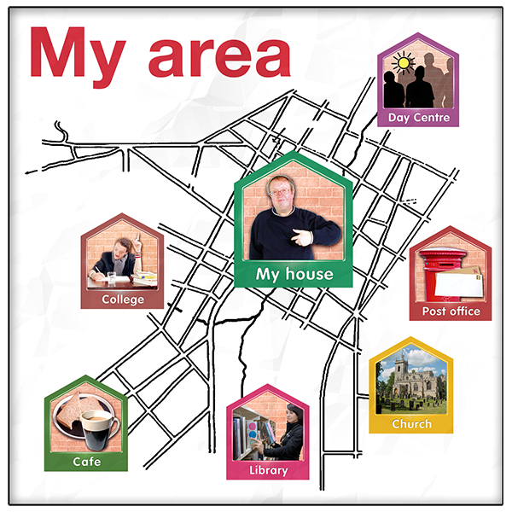 | Community is a group of people who live in an area or who have something in common.  Services sometimes talk about geographical communities, communities of interest and communities of identity  A geographical community is a group of people who live in an area. That could be a town, a village, or a country.  A community of interest is a group of people who share hobbies or who do similar things like a fishing group or an online gaming group.  A community of identity is a group of people who have things about themselves in common like disability, sex, gender, race, or religion.

Some examples of how community engagement is carried out are:

- Filling in a survey about how you feel about services you use

- Working with others to write a response to a consultation

- Taking part in a focus group where you talk about your experiences using services.

A focus group is a small group of people who answer questions and share their feelings and ideas with someone from a service organisation or a researcher.

- Going to a community event and talking about what you think could be done to make your community better

How does community engagement happen?

Why is community engagement important?
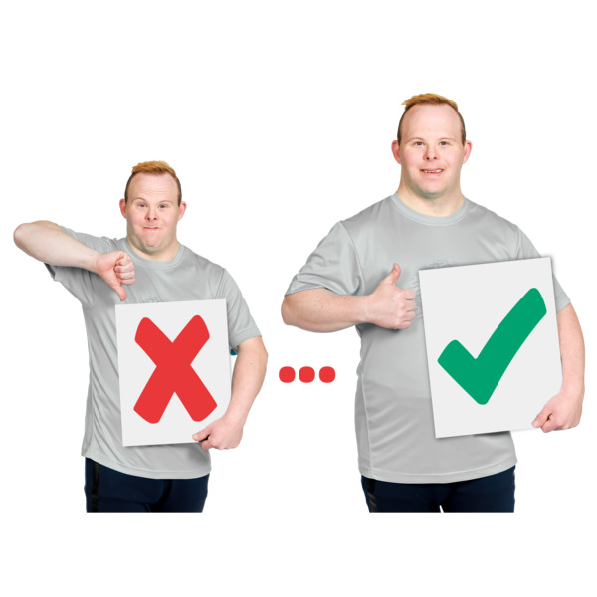 | Community engagement is important because it can lead to people working with organisations to improve services and make their community better for everybody.  The important values are:  - effective – it meets the needs and hopes of the people involved  - efficient – it is well organised and planned  - fair – it supports people to take part including people who are socially excluded
 | Social exclusion is when some groups of people find it harder to access services because of things like their age, disability, race or where they live.
Good community engagement involves:

• making plans, choices and decisions together

•working together to achieve community goals

• people in the community controlling the actions that achieve these goals

The Community Empowerment (Scotland) Act 2015

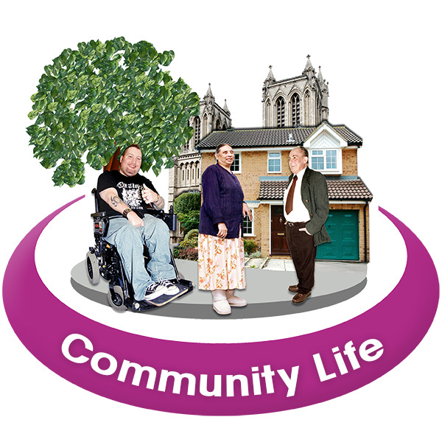 | The Community Empowerment (Scotland) Act 2015 is a law that says people should have more control over what happens in their community and they should be involved in making decisions about their community.  This law says that the people who make decisions should involve people who live in local areas.

The National Standards for Community Engagement
The National Standards for Community Engagement talk about the best ways to help get people involved.

They are an easy guide to make sure everyone can take part in community engagement and get good results.

Click here to open an Easy Read version of the standards.

