What is Community Development?

September 2023

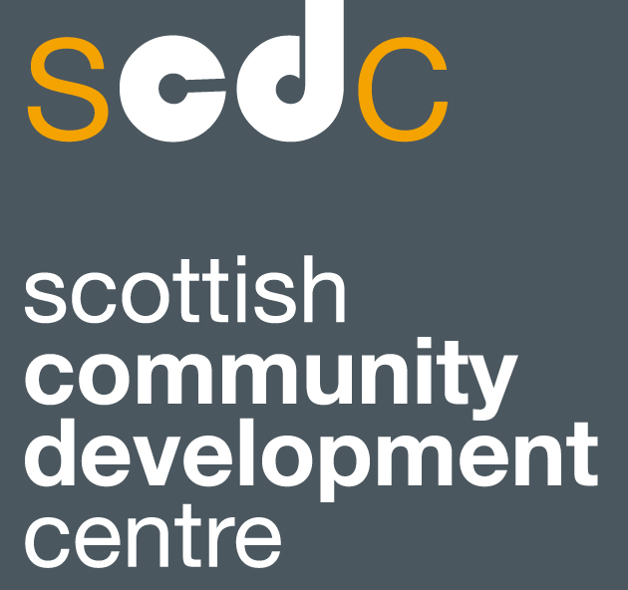

Copyright images © Photosymbols. Prepared by Scottish Community Development Centre
Introduction
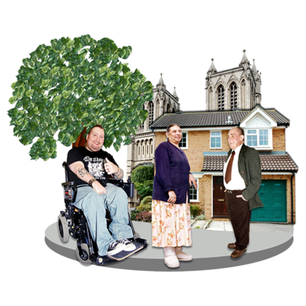 | Community development is when people work together to make things better for their community.
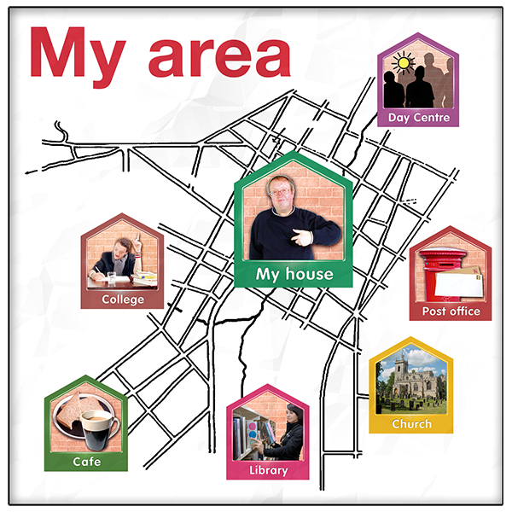 | Community is a group of people who live in an area or who have something in common.  Services sometimes talk about geographical communities, communities of interest and communities of identity  A geographical community is a group of people who live in an area. That could be a town, a village, or a country.  A community of interest is a group of people who share hobbies or who do similar things like a fishing group or an online gaming group.  A community of identity is a group of people who have things about themselves in common like disability, sex, gender, race, or religion.
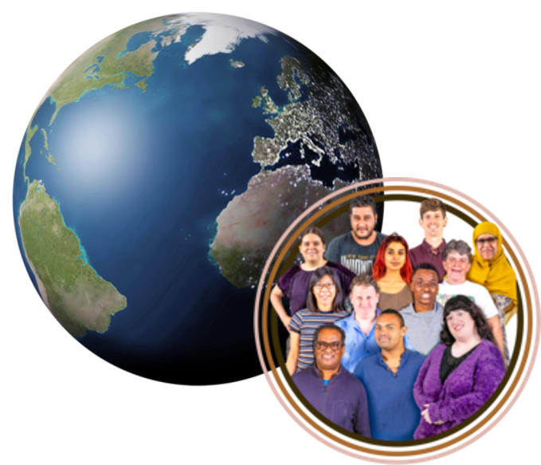 | Community development is a way of working that happens all around the world.
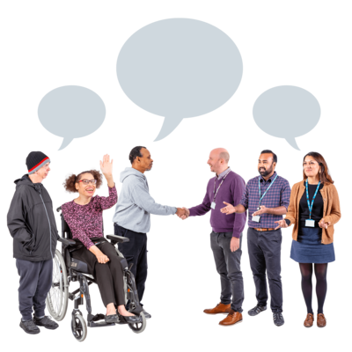 | It is based on the idea that unfairness, discrimination, and inequality cannot be fixed by the government or by people who run services like the Council, NHS, or police on their own.  Services should work with communities.
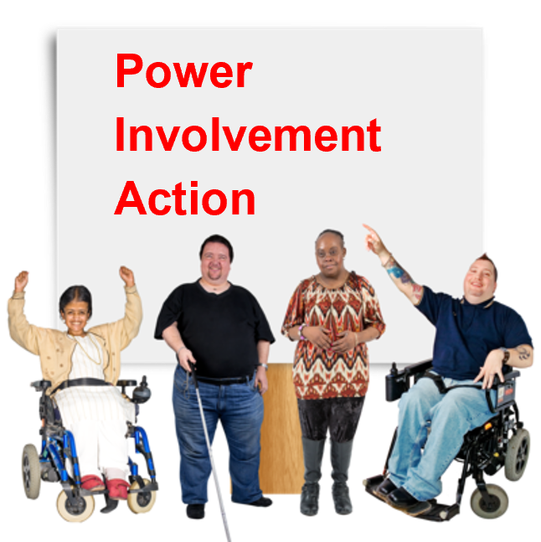 | The important values of community development are:  - communities having the power to make things happen  - communities being involved in saying how things should be done  - making sure everyone can get involved  - communities being able to choose and control what they do  - working together with others

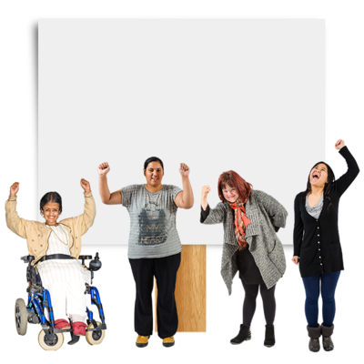 | To make this happen we need to:  - build strong community groups and organisations  - help people develop their skills or learn new skills  - make sure communities know about the opportunities there are to let people in power know what they think

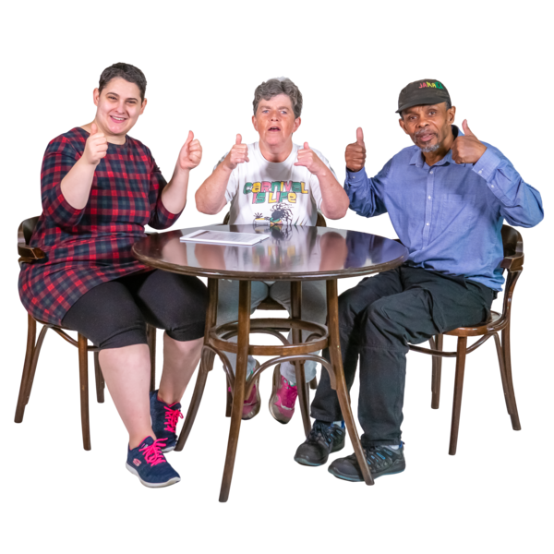  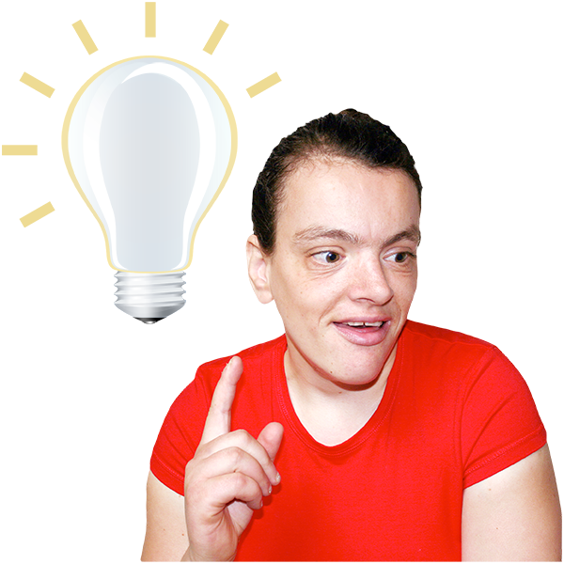 | Community development happens when someone gets people excited about an idea and encourages other people in the community to help them to do something to make things better.  Sometimes when people who are not part of a group have an idea, they start up a new group with people who share their idea.

Making stronger communities

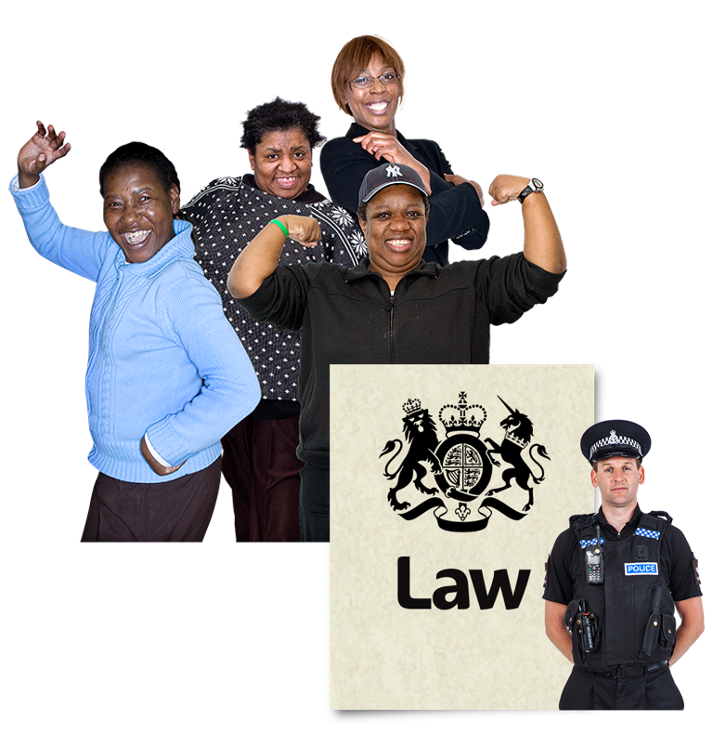 | Great strengths and knowledge can be found in communities.  Sometimes it can be difficult for people to put these strengths to use when they are a carer for someone, if they are worried about things like money or their health, or when things in their community change quickly.  Community development workers or organisations can help communities to take their ideas forward and use some of the laws that have been put in place to give communities more power.

How does community development happen?

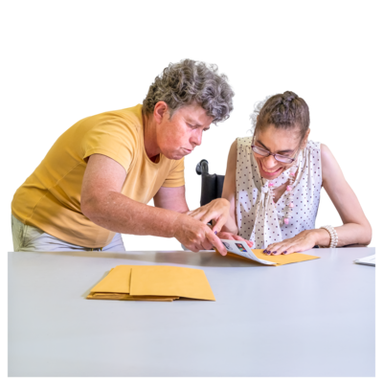 | The need for change often comes from communities or community groups.  People who are experienced and trained in supporting community development can help.
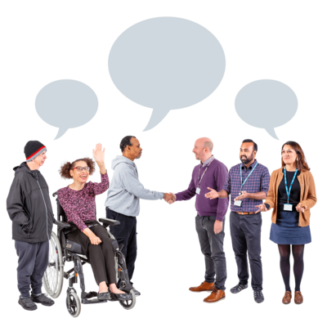 | This includes:  - helping people to come together to decide what they want to change and finding ways of doing it  - helping people learn new skills, find out more and become more confident  - helping people to understand and do something about social exclusion and unfairness  - supporting community groups to work well and to make sure they represent the views of their community  - supporting community groups to manage their money, follow the law and run their group well  - supporting community groups to get involved in talking to decision makers like the Council and the NHS to help decide how services should be run
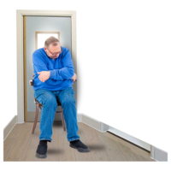 | Social exclusion is when some groups of people find it harder to access services because of things like their age, disability, race or where they live.

Where do community development workers work?

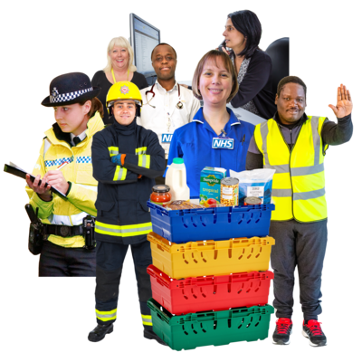  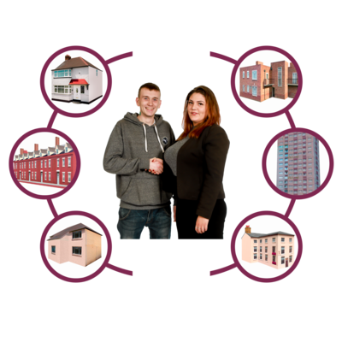 | In Scotland, skilled community development workers can be found in lots of community groups and organisations like:  - Housing Associations  - Councils – usually called Community Learning and Development Teams  - Community Planning Partnerships  - The NHS  - Charities and organisations working in communities.  Community Planning Partnerships bring together public bodies like the Council, NHS, police, and fire service to plan services for local communities.  People in other jobs can learn from the community development approach and work in ways that help people get involved in having a say.

